Assignment 10 – Chatbot Project

Human Language Technologies

CS 4395.001

Ethan Ong – ELO180000

**System Description**

For The chatbot, I decided to create my own chatbot system instead of using a preexisting one like the one that were provided on the PDF. This is because I’ve done something similar to this before using Intents (required_words and response). The bot accepts the users input and uses keyword that the user specifies. The program then uses those specific words and the Chatbot replies back with a question or a statement for the user.

The chatbot utilizes Stemming, tokenizing and lemmatizing. This allows the program to be able to break up the user input. Then it gets POS tagged. Pos tagged because there are going to be many nouns and verbs that have the same form. So This would allow it to be distinguished a lot easier and faster.

I made this bot so It can tell use about the US geography is that it will tell the user the city and state with the population and etc. When a user inputs a city it would reply back the state that it correlates to. The bot will also remember the user’s input and saves it and if the user comes back the bot will remember and displays the user favorite city the user has visited. When a user ask the bot “Where should I go next?” The bot will pick a random place and the bot will reply with a city and state for the user.

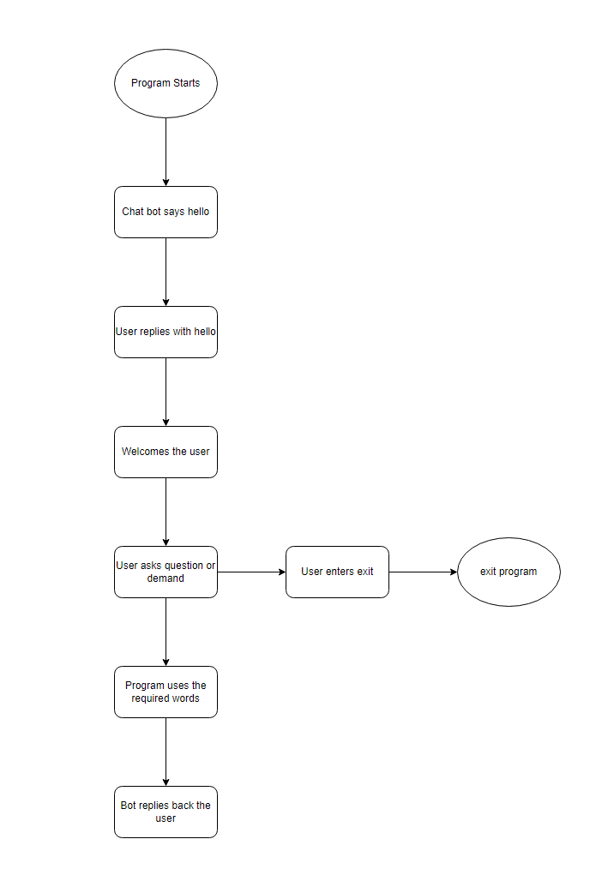

**Sample**

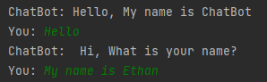

Below 2: Shows user favorite city they visit

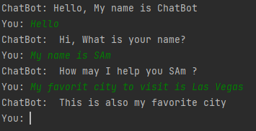

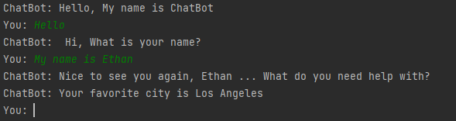

Below: Give the user a random city and information about that city

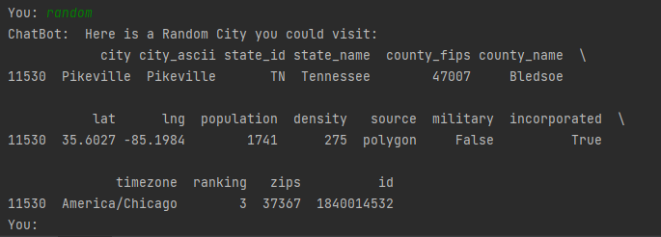

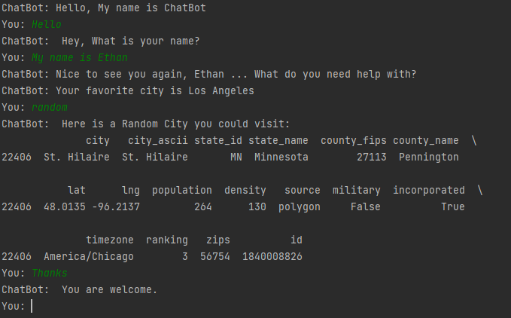

Below: Give the user with a city of their choosing and information about that city

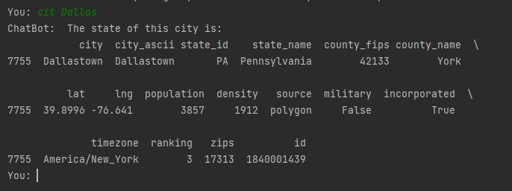

Below: User quits the program

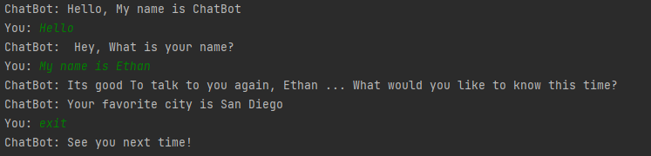

**Knowledge Base**

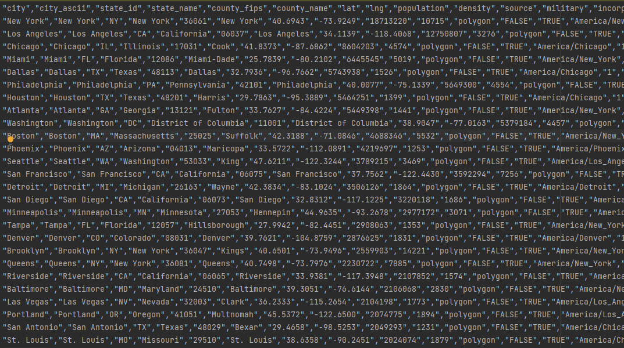

**Evaluation**

1. Chatbot was able to identify favorite city to visit

Average Score: 3

Feedback: Could be have an easier way of

1. Chatbot gave random city to visit

Average Score: 4

Feedback:

1. Chatbot was able to give me city and state

Average Score: 3.5

Feedback: “Bot was not always able to understand what I was trying to ask”

1. Chatbot was able to remember who I was

Average Score: 5

Feedback: “The required_word could be better in that could use others instead of just name”

1. Chatbot was able to give me the population of certain city

Average Score: 4

Feedback: